Art Critique
Student’s Name
Instructor’s Name
Date

Art Critique
When I visited the southeast museum in Texas, I encountered two pieces of artwork that got my attention. The first artwork was a painting with the name JOOYOUNG CHOI, which had been painted by an artist whose name had not been disclosed. The artist used acrylic media to paint the artwork. The second artwork was much of animated features. Therefore, the entire of this essay is going to critique these two artistic photos.
First Photo

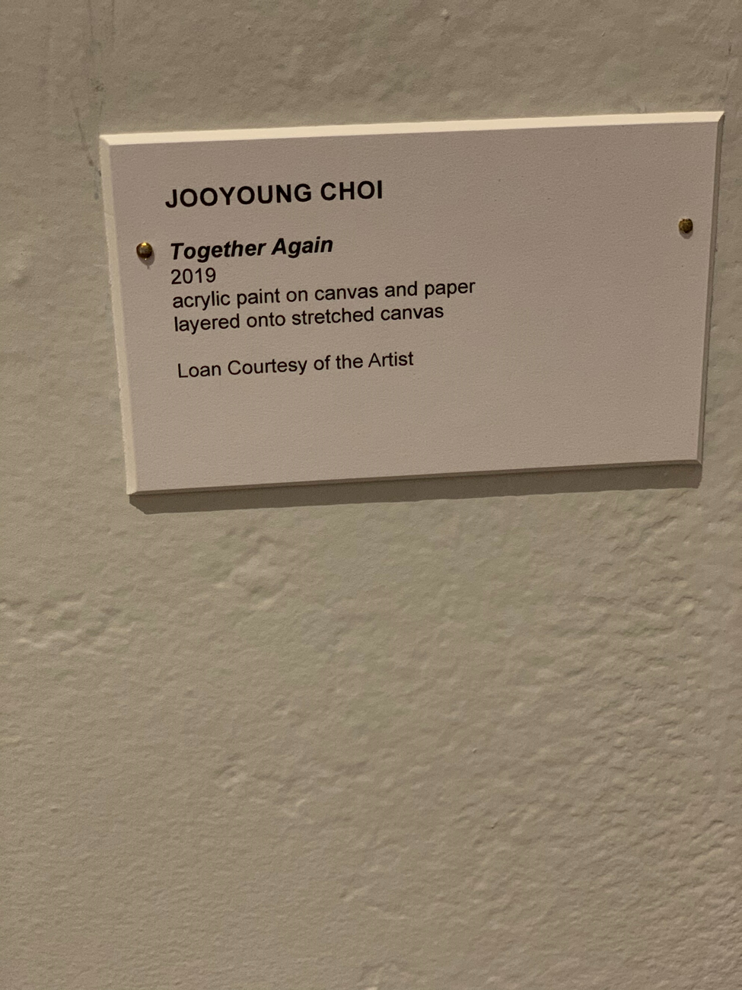
The painting is appealing. This is because of the different artistic styles used crafting the shot. The use of black color that is intensified and bolded has increased the artistic styles. The name “JOOYOUNG CHOI” and “Together Again” is bolded to increase the visibility of the paintwork. The rest of the painting including the year “2019” and writings like “acrylic paint on canvas and paper layered onto stretch canvas” and “Loan Courtesy of the artist” are painted with less intense black color which increases the beauty of the artwork. The artwork appears to be a memorable scene that will most likely attract the attention of the visitors at the museum. The photo makes it easier for the visitors to click a short without wasting time to arrange the photo artistically as this has already been achieved. The background color of the artwork is vibrant enough to capture the eyes of the audience. The lighting of the photo is also impressive. As a result, the lighting has enhanced the quality of the photo. The scenescape is also great which makes visitors have a great ability for taking a cool shot. I love the textures included in the composition of this shot. The letters on the top have different fonts style from the lower one. The difference increases the texture of the artwork. However, the picture would have been more appealing if a vibrant background would have been used.
The Second Photo
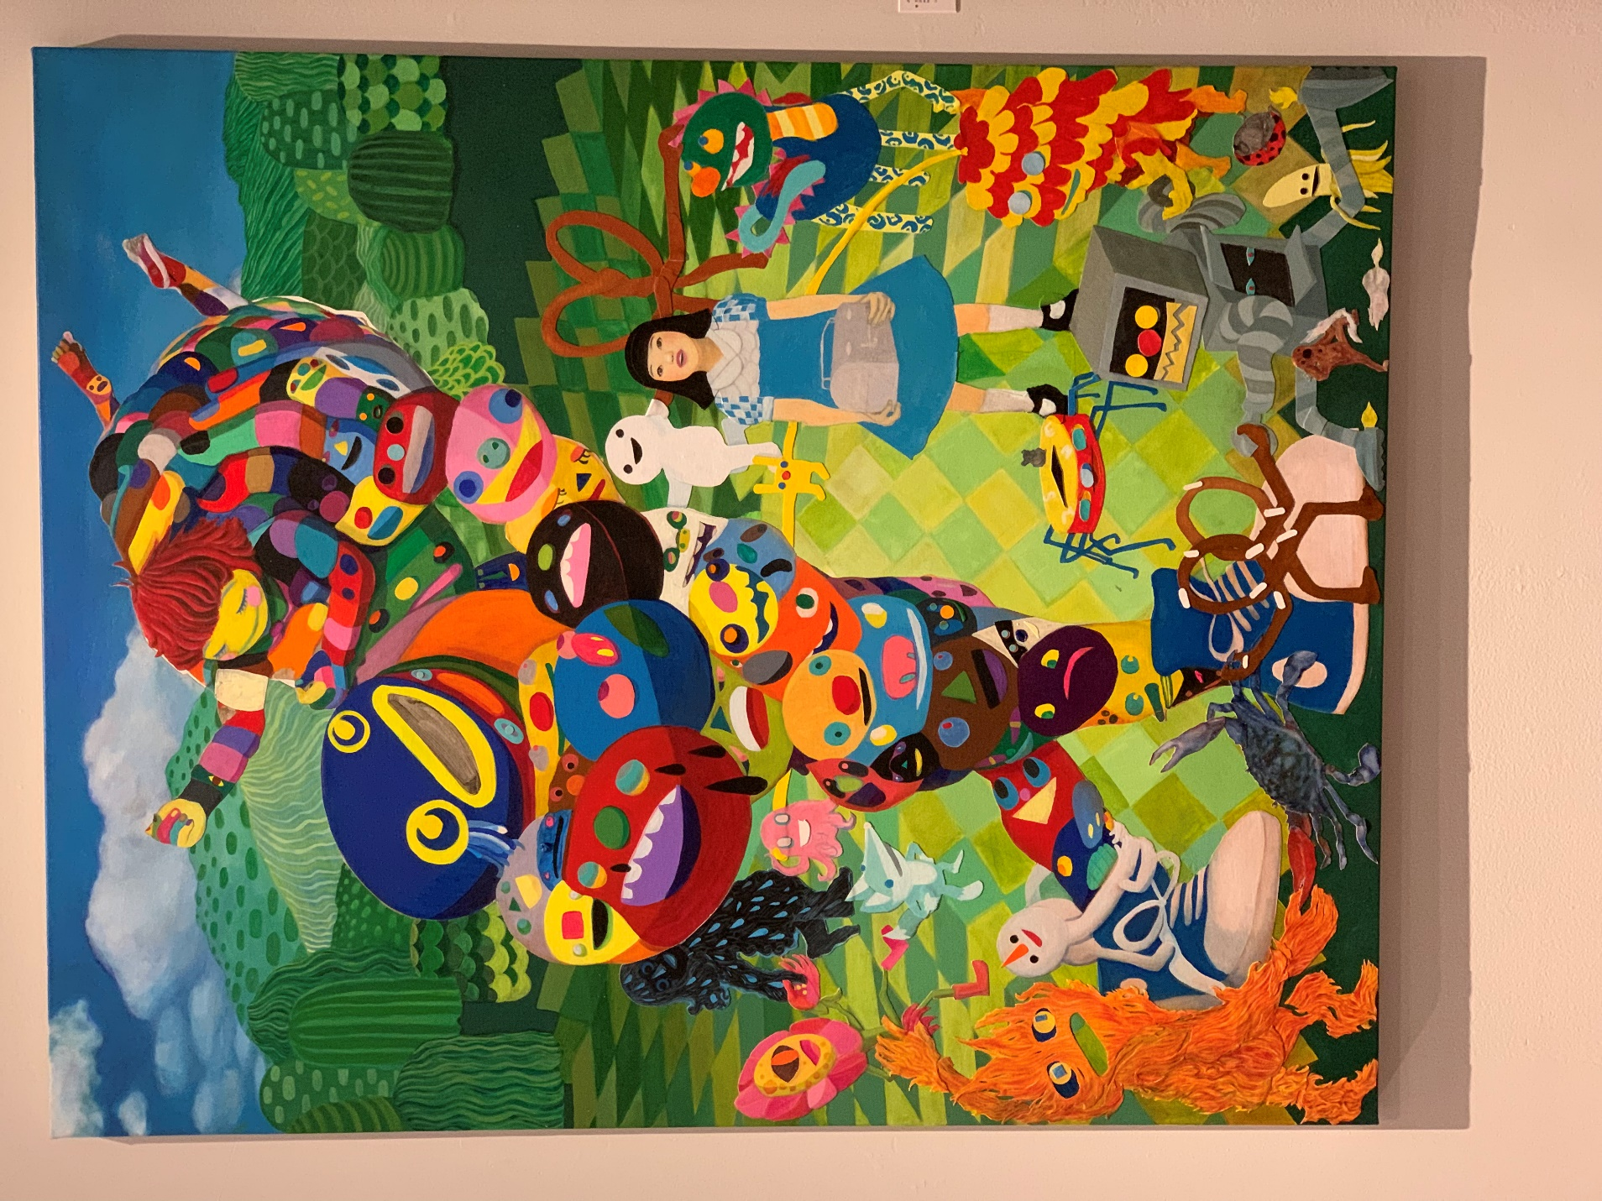

I am pleased that the shot captures the sights and sound of visitors to the museum. You can see a young girl, various animals, different types of shoes all being animated. The colors are vibrant enough to attract visitors. The perspective of the shot uses the features in the foreground with various combination of colors, makes one to automatically sense that he is in a different scene that is much appealing. The framing of the shot creates a feeling that you are in an enticing environment. I love the different paintings captured in the shot have different artistic features. Due to the lighting, the flow begins from the lightest area of the image (the animals and the girl on left and right, the animated animals at the bottom left and the colorful paintings in the midst of the shot).
The mountain-like features are visible at the top of the shot painted in dark green increases the texture of the shot. The appearance of a girl holding a piece of wood, some cartoons attached to bluish shoes and the scrub that is painted adjacent to the shoes makes the shot more appealing. The animated kid at the top after the mountainous paintings above the dolls makes the shot have a discrete flow.
The entire scene appears to be pretty much comprised of greens, pink, maroon, and yellow. At the edge where the frame is more of the bright pink color of the blooming paintings of trees and dolls brings a cool spring of happy feeling. I impressed that this is more of a typical scene of the natural environment found in a home. This is because the visible features are those of paintings that can even be used to decorate a house. Kids are playing, other kids hanging out, various paintings representing insects and small animals such as scrubs are used to represent a range of opinions under one picture. All these features are used to attract the audience.
In conclusion, the two artistic paintings are appealing and show a great deal of artwork. However, in the first picture, the art would be exclusive if the message in the painting would be specific like a motivational message, an inspiration, or a philosophical saying. For the second picture, it would be fascinating if the paintings would be easily distinguished from one another. Several paintings in the second artistic are mixed and embedded together, and this makes it difficult for the audience to distinguish or drive a substantial meaning from the painting. Therefore, the artist ought to have articulated each painting distinctively.

